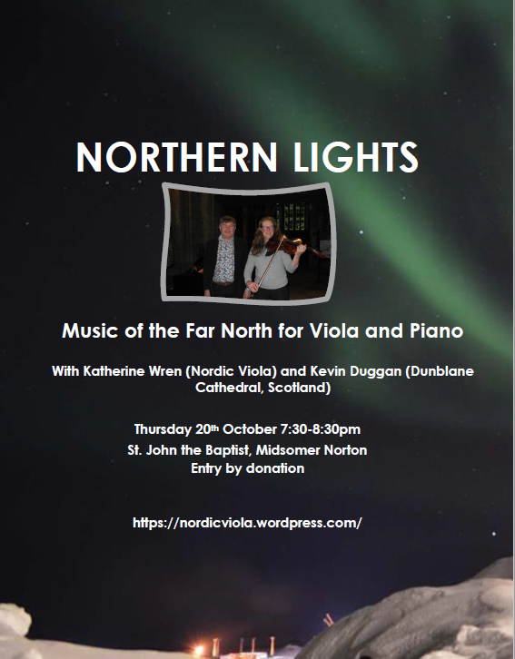

Katherine Wren (viola) and Kevin Duggan are two musicians with strong ties to the Far North and Scandinavia but with many links to the South West of England!
In their Northern Lights programme they embrace the coming winter with a feeling of hygge and a trip to Greenland.
The programme opens with a Rebecca Clarke’s gentle arrangement of I Bid My Heart be Still, a melody from the Scottish Borders. The icy vastness of Greenland has been a major source of inspiration to Reading-based composer Adrian Vernon Fish and yet, in his sonata Qaanaaq (a settlement in the far north-west of Greenland) there is much human warmth – not to mention a humorous and rollicking dog-sled ride. Kevin Duggan’s atmospheric rendering of the hymn Almáttugur Guð plants us firmly in Iceland, where we finish with Jón Thorarinsson’s engagingly melodic and jazzy Sonata.
Katherine Wren studied music at the University of Manchester and the Royal Northern College of Music. She is a currently a member of the Royal Scottish National Orchestra. In September 2016 she formed Nordic Viola, a flexible ensemble performing and promoting music from the countries encircling the North Atlantic and the ensemble have performed in the Faroes and Iceland as well as throughout Scotland.
Katherine received a Special Commendation in the 2020 RPS/ABO Salomon Prize for her contribution to all aspects of orchestral life and her work with Nordic Viola, cited as “a fulfilling new experience for players that has forged lasting links with these communities.” nordicviola.wordpress.com/about/
Kevin Duggan read music at Bath University and the Royal College of Music in London.
Since 2015 he has been Director of Music of Dunblane Cathedral in Scotland. He is also Organist for RSCM Scottish Voices and an examiner for ABRSM.
His recent CD recording, Hymne Ærø comprises Danish music performed on the superb Flentrop organ in Dunblane Cathedral. Produced by Odradek Records, this recording has received favourable reviews in Choir and Organ, RSCM Church Music Quarterly and in the Danish press. It is available online and via www.dunblanecathedral.org.uk

