ST JOHN the BAPTIST, MIDSOMER NORTON
APPLICATION FORM FOR PARISH ADMINISTRATOR
Closing date for Applications: 30th November 2017
Interview Date: 8th December 2017
Please return completed application forms to msnparishoffice@aol.com
or by post
marked 'Private and Confidential' to St John's Parish Office, The Church Hall,
Church Square, Midsomer Norton BA3 2HX
Please complete this form as fully as you can, and enlarge any text boxes
as necessary. If you have any questions or queries, please do not hesitate
to contact us on
Post applied for: |  |  | Parish Administrator
Where did you see the post
advertised?
PERSONAL DETAILS
Title
Surname
Forename(s)
Address
Work tel. no.
Home tel. no.
Mobile tel. no.
E-mail
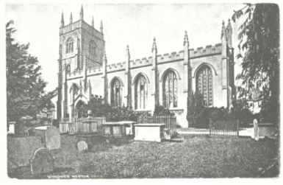 |  |  | 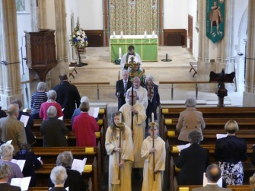 |  |  | 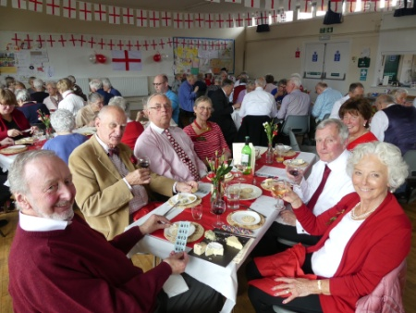
Parish Administrator at St John the Baptist, MSN
Page 2
CURRENT (OR MOST RECENT) EMPLOYMENT
Post
Employer
Date from/to
Summary of
responsibilities
PREVIOUS POSTS (Most recent first)
Employer |  | Post |  | From | To | Summary of responsibilities
Parish Administrator at St John the Baptist, MSN
Page 3
EDUCATION AND QUALIFICATIONS (Most recent first)
School/college/university .. |  |  |  | From | To | Qualifications
OTHER RELEVANT EXPERIENCE
Training and personal
development in office work
and management
Knowledge of computer
systems, databases,
Publisher, PowerPoint, print
design, web design etc.
Personal Interests
A key quality in the person
specification is 'someone in
sympathy with the vision
and ethos of St John the
Baptist Church'. If successful
please describe how you
would seek to fulfil your role
within this criteria.
(please note this post does not have a
Genuine Occupational Requirement
(GOR) for the post-holder to be a
Christian and we will consider all
applications equally)
Parish Administrator at St John the Baptist, MSN
Page 4
STATEMENT IN SUPPORT OF YOUR APPLICATION
Please indicate clearly how your skills and experience meet the requirements of the post as set out
in the Job Description. You are advised to consider carefully where your skills would contribute to the
successful undertaking of the different key tasks within this role, and evidence of where your experience
would satisfy the essential and desirable criteria of the person specification.
(Continue on a sepate sheet if necessary)
Parish Administrator at St John the Baptist, MSN
Page 5
ADDITIONAL QUESTIONS
If successful, what is the earliest date
that you could start the job?
Do you have any special need or
disability which might affect your
ability to carry out the tasks required
by the post, and for which we may
make arrangements should you be
called for interview?
REFEREES
Please provide details of three referees, including your present or most recent employer. If you are a member of a
Church you may want to include a reference from your Church leader or equivalent.
 | Name
 | Position
 | Address
1
 | Tel. no.
 | E-mail
May we approach before interview |  |  |  |  | YES |  | NO
 | Name
 | Position
 | Address
2
 | Tel. no.
 | E-mail
May we approach before interview |  |  |  |  | YES |  | NO
 | Name
 | Position
 | Address
3
 | Tel. no.
 | E-mail
May we approach before interview |  |  |  |  | YES |  | NO
Parish Administrator at St John the Baptist, MSN
Page 6
SAFEGUARDING and VULNERABLE ADULTS POLICY
This position involves some contact with children, young people and vulnerable adults, and
this recuitment is therefore subject to the current vetting and barring procedures in line
with diocesan policy and current DBS guidelines and legislation. A copy of the St John the
Baptist's Child Protection and Safeguarding Policy can be made available before interview.
Do you have any convictions that are not "spent"
within the meaning of the Rehabilitation of |  |  |  |  |  | YES |  | NO
Offenders Act 1974?
Because of the nature of the work you are applying for, this post is exempt from the provisions of Section4(2) of the
Reabilitation of Offenders Act 1974 by virtue of the Rehabilitation of Offenders Act (exemptions) Order 1975. This means
that you are not entitled to withhold information about convictions which for other purposes are "spent" under provisions
of the Act. In the event of employment, failure to disclose such convictions could lead to disciplinary action being taken.
Any information will be treated in the strictest of confidence and used solely in relation to this application.
DECLARATION
I declare that the statements made by me in this application are true and that the accuracy
thereof shall be a condition of any contract of employment offered to me by the PCC of
St John the Baptist Church, Midsomer Norton.
Signature of Applicant
Date
Date received

